**Crappy Bird Game**

1. **Start Game and Pause Game**

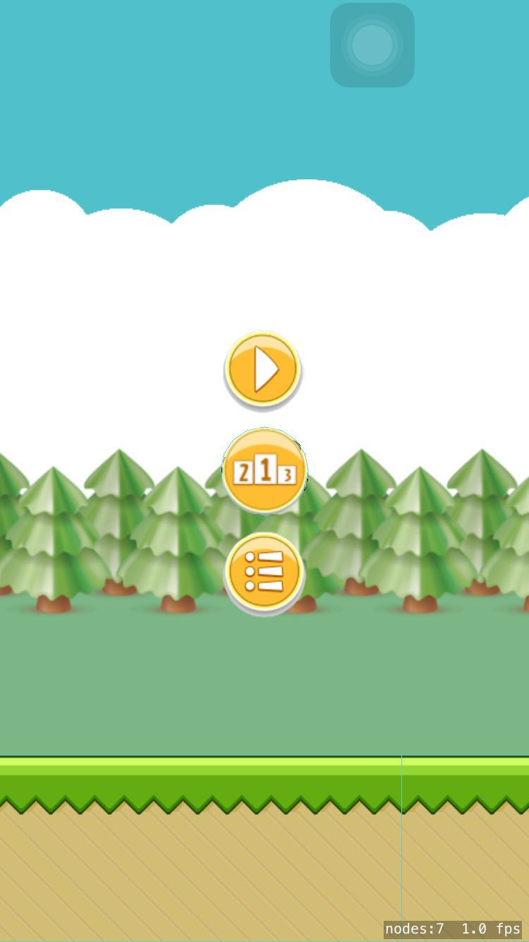

1. **Play Game and Score Display**

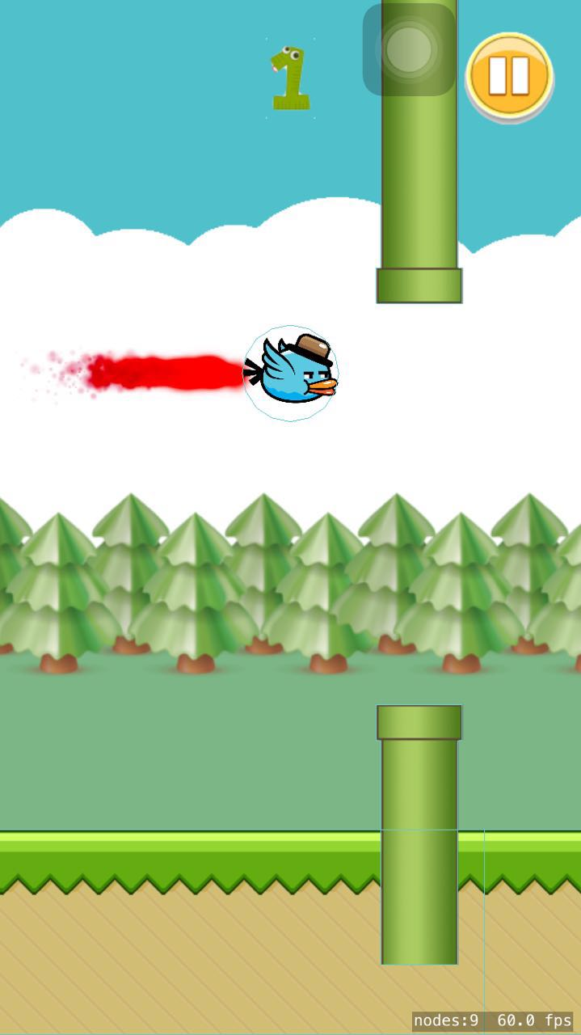

1. **Submit and Quit when your bird dies, entering your name and university name will upload your info to Firebase.**

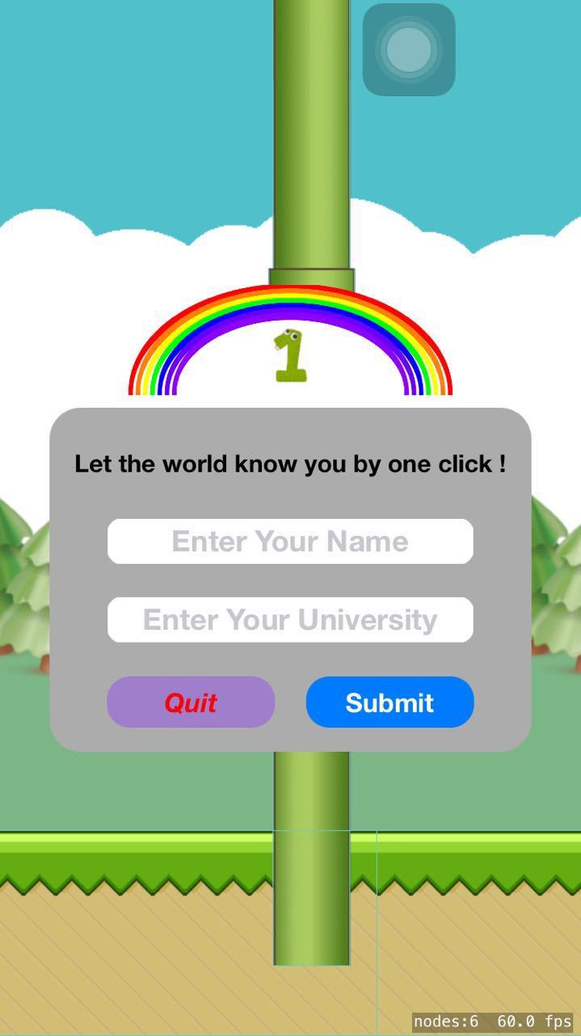

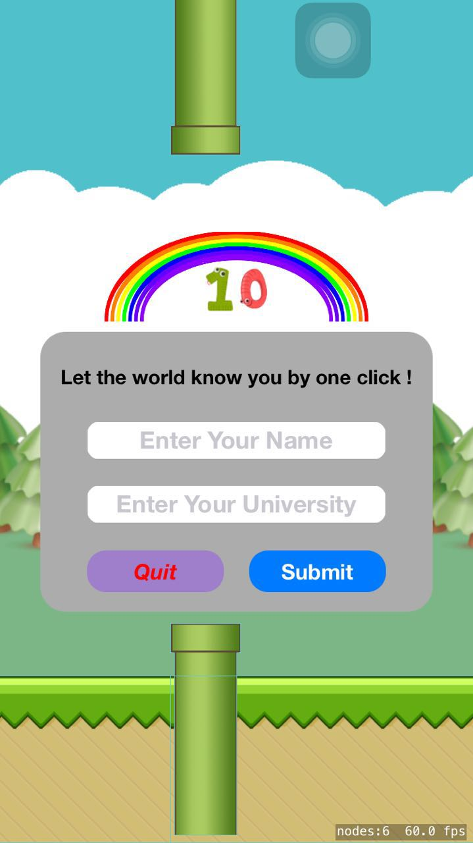

1. **After Quit or Submit, you can start again.**

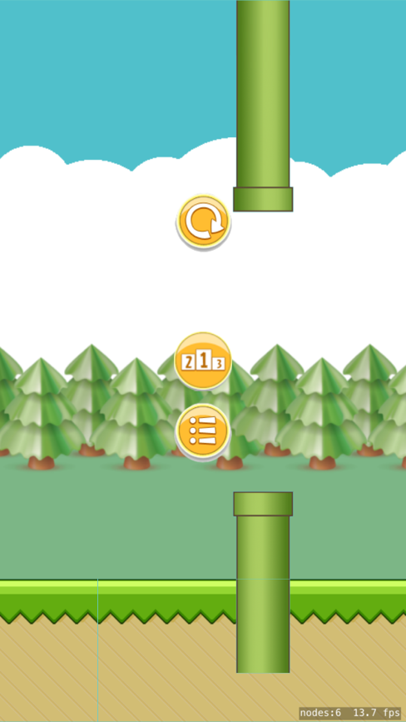

1. **Click the Rank button to see who else are also on the ranking list, Ordered by scores, can also see their names and where they from.**

